SIMATS ENGINEERING

ASSESSMENT TOOL 1 – High (Coding Challenge)

COURSE CODE: CSA09 COURSE NAME: Programming in Java COURSE OUTCOME COVERED
CO1: Apply object-oriented programming principles such as classes, objects, encapsulation, data hiding, inheritance, and polymorphism to design and implement entity manipulations (BL3,BL4)

QUESTIONS: 5 Total Marks: 100
ANNEXURE A Coding Challenge
Code of Conduct:
I (Name / Reg No) certify that this submission is my original work and that I have adhered to the guidelines specified for this assessment. I understand that any violation of academic integrity rules will result in disciplinary action.
Signature of the student:

RUBRICS FOR CALCULATION:
Criteria | Weightage | Level 4 (Exemplary) | Level 3 (Proficient) | Level 2 (Developing) | Level 1 (Beginning)
Problem Understanding | 20% | Clearly understands problem constraints, edge cases, and  competitive requirements | Understands problem with minor gaps in constraints | Partial understanding; misses key constraints | Misinterprets problem or constraints
Algorithm | 25% | Selects optimal algorithm with best time and space complexity for competitive constraints | Uses efficient algorithm with minor scope for improvement | Uses basic/inefficient approach | No clear algorithmic approach
Code Implementation | 20% | Writes correct, efficient, and clean  code that passes all constraints | Code works with minor errors or inefficiencies | Partially correct code; fails for some cases | Code does not execute or gives incorrect results
Competitive Performance | 20% | Solves problem within time limits  and handles large inputs effectively | Solves within acceptable time with minor delays | Struggles with time limits or larger inputs | Unable to solve within time constraints
Test Case Handling | 15% | Handles all test cases including  edge and hidden cases | Handles most test cases | Misses important edge cases | Fails on multiple test cases

ANNEXURE

Coding Challenge

- Library Book Management using Classes & Encapsulation

Design a Book class with private fields such as bookId, title, author, and price. Implement constructors, getters, setters, and methods to issue and return books. Create a menu-driven program to manage multiple books using an array of objects. Also, construct suitable test cases to validate book addition, issue, return, and search operations.BTL: BL3 (Apply)
import java.util.Scanner;

class Book {
private int bookId;
private String title;
private String author;
private double price;
private boolean issued;

// Constructor
public Book(int bookId, String title, String author, double price) {
this.bookId = bookId;
this.title = title;
this.author = author;
this.price = price;
this.issued = false;
}

// Getters
public int getBookId() {
return bookId;
}

public String getTitle() {
return title;
}

public String getAuthor() {
return author;
}

public double getPrice() {
return price;
}

public boolean isIssued() {
return issued;
}

// Setters
public void setTitle(String title) {
this.title = title;
}

public void setAuthor(String author) {
this.author = author;
}

public void setPrice(double price) {
this.price = price;
}

// Issue Book
public void issueBook() {
if (!issued) {
issued = true;
System.out.println("Book issued successfully.");
} else {
System.out.println("Book is already issued.");
}
}

// Return Book
public void returnBook() {
if (issued) {
issued = false;
System.out.println("Book returned successfully.");
} else {
System.out.println("Book was not issued.");
}
}

// Display Details
public void displayBook() {
System.out.println("--------------------------------");
System.out.println("Book ID : " + bookId);
System.out.println("Title : " + title);
System.out.println("Author : " + author);
System.out.println("Price : " + price);
System.out.println("Status : " + (issued ? "Issued" : "Available"));
}
}

public class Main {

public static void main(String[] args) {

Scanner sc = new Scanner(System.in);

Book books[] = new Book[100];
int count = 0;
int choice;

do {
System.out.println("\n===== LIBRARY MANAGEMENT =====");
System.out.println("1. Add Book");
System.out.println("2. Display Books");
System.out.println("3. Search Book");
System.out.println("4. Issue Book");
System.out.println("5. Return Book");
System.out.println("6. Exit");
System.out.print("Enter Choice: ");

choice = sc.nextInt();

switch (choice) {

case 1:

System.out.print("Enter Book ID: ");
int id = sc.nextInt();

sc.nextLine();

System.out.print("Enter Title: ");
String title = sc.nextLine();

System.out.print("Enter Author: ");
String author = sc.nextLine();

System.out.print("Enter Price: ");
double price = sc.nextDouble();

books[count] = new Book(id, title, author, price);
count++;

System.out.println("Book Added Successfully.");

break;

case 2:

if (count == 0) {
System.out.println("No Books Available.");
} else {
for (int i = 0; i < count; i++) {
books[i].displayBook();
}
}

break;

case 3:

System.out.print("Enter Book ID to Search: ");
int searchId = sc.nextInt();

boolean found = false;

for (int i = 0; i < count; i++) {

if (books[i].getBookId() == searchId) {
books[i].displayBook();
found = true;
break;
}
}

if (!found)
System.out.println("Book Not Found.");

break;

case 4:

System.out.print("Enter Book ID to Issue: ");
int issueId = sc.nextInt();

found = false;

for (int i = 0; i < count; i++) {

if (books[i].getBookId() == issueId) {
books[i].issueBook();
found = true;
break;
}
}

if (!found)
System.out.println("Book Not Found.");

break;

case 5:

System.out.print("Enter Book ID to Return: ");
int returnId = sc.nextInt();

found = false;

for (int i = 0; i < count; i++) {

if (books[i].getBookId() == returnId) {
books[i].returnBook();
found = true;
break;
}
}

if (!found)
System.out.println("Book Not Found.");

break;

case 6:

System.out.println("Thank You!");
break;

default:

System.out.println("Invalid Choice.");
}

} while (choice != 6);

sc.close();
}
}

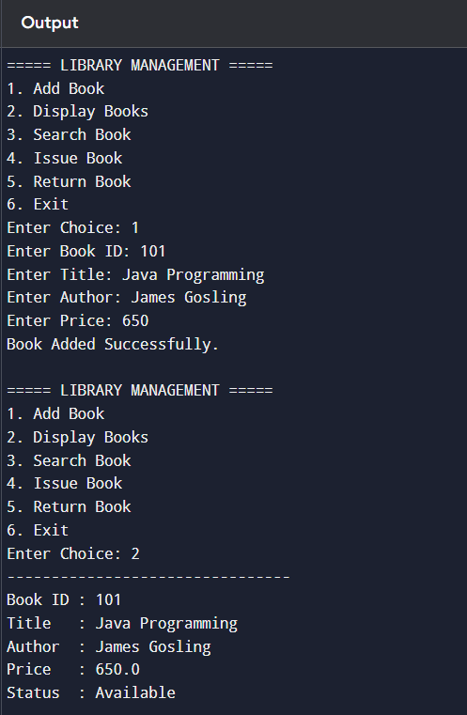
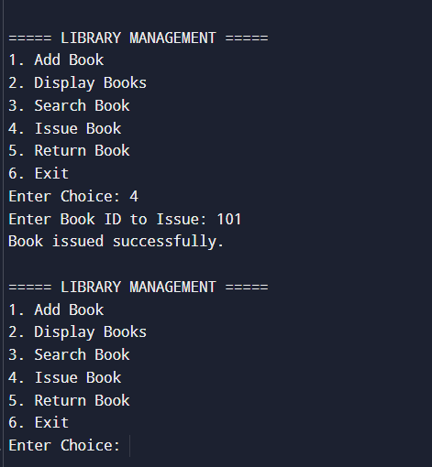

Employee Payroll System using Inheritance

Design a payroll system with a base class Employee and derived classes PermanentEmployee and ContractEmployee. Override a method calculateSalary() in each subclass to compute salary differently. Display employee details and salary using runtime polymorphism. Also, construct suitable test cases to validate salary calculation for different employee types.BTL: BL3 (Apply)
import java.util.Scanner;

// Base Class
class Employee {
protected int empId;
protected String empName;

Employee(int empId, String empName) {
this.empId = empId;
this.empName = empName;
}

public double calculateSalary() {
return 0;
}

public void displayDetails() {
System.out.println("Employee ID : " + empId);
System.out.println("Employee Name : " + empName);
}
}

// Derived Class - Permanent Employee
class PermanentEmployee extends Employee {

private double basicSalary;
private double hra;
private double da;

PermanentEmployee(int empId, String empName,
double basicSalary, double hra, double da) {

super(empId, empName);

this.basicSalary = basicSalary;
this.hra = hra;
this.da = da;
}

@Override
public double calculateSalary() {
return basicSalary + hra + da;
}
}

// Derived Class - Contract Employee
class ContractEmployee extends Employee {

private int hoursWorked;
private double ratePerHour;

ContractEmployee(int empId, String empName,
int hoursWorked, double ratePerHour) {

super(empId, empName);

this.hoursWorked = hoursWorked;
this.ratePerHour = ratePerHour;
}

@Override
public double calculateSalary() {
return hoursWorked * ratePerHour;
}
}

// Main Class
public class Main {

public static void main(String[] args) {

Scanner sc = new Scanner(System.in);

Employee emp;

System.out.println("===== EMPLOYEE PAYROLL SYSTEM =====");
System.out.println("1. Permanent Employee");
System.out.println("2. Contract Employee");
System.out.print("Enter Choice: ");

int choice = sc.nextInt();

System.out.print("Enter Employee ID: ");
int id = sc.nextInt();

sc.nextLine();

System.out.print("Enter Employee Name: ");
String name = sc.nextLine();

switch (choice) {

case 1:

System.out.print("Enter Basic Salary: ");
double basic = sc.nextDouble();

System.out.print("Enter HRA: ");
double hra = sc.nextDouble();

System.out.print("Enter DA: ");
double da = sc.nextDouble();

emp = new PermanentEmployee(id, name, basic, hra, da);

break;

case 2:

System.out.print("Enter Hours Worked: ");
int hours = sc.nextInt();

System.out.print("Enter Rate Per Hour: ");
double rate = sc.nextDouble();

emp = new ContractEmployee(id, name, hours, rate);

break;

default:

System.out.println("Invalid Choice");
sc.close();
return;
}

System.out.println("\n------ Employee Details ------");
emp.displayDetails();
System.out.println("Salary : " + emp.calculateSalary());

sc.close();
}
}

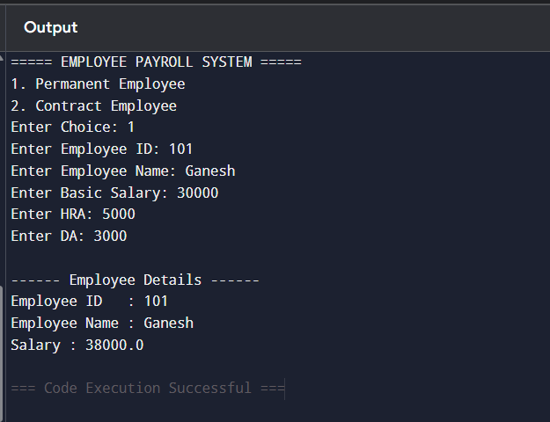

Bank Account System using Data Hiding

Design a BankAccount class with private fields accountNumber, holderName, and balance. Implement methods for deposit, withdrawal, and balance inquiry with proper validation. Prevent direct modification of balance from outside the class. Also, construct suitable test cases to validate valid and invalid transactions.BTL: BL3 (Apply)
import java.util.Scanner;

class BankAccount {

// Private Data Members (Data Hiding)
private int accountNumber;
private String holderName;
private double balance;

// Constructor
public BankAccount(int accountNumber, String holderName, double balance) {
this.accountNumber = accountNumber;
this.holderName = holderName;
this.balance = balance;
}

// Deposit Method
public void deposit(double amount) {

if (amount > 0) {
balance += amount;
System.out.println("Amount Deposited Successfully.");
} else {
System.out.println("Invalid Deposit Amount.");
}
}

// Withdraw Method
public void withdraw(double amount) {

if (amount <= 0) {
System.out.println("Invalid Withdrawal Amount.");
}
else if (amount > balance) {
System.out.println("Insufficient Balance.");
}
else {
balance -= amount;
System.out.println("Withdrawal Successful.");
}
}

// Display Account Details
public void displayAccount() {
System.out.println("\n------ Account Details ------");
System.out.println("Account Number : " + accountNumber);
System.out.println("Holder Name : " + holderName);
System.out.println("Balance : " + balance);
}

// Balance Inquiry
public void displayBalance() {
System.out.println("Current Balance : " + balance);
}
}

public class Main {

public static void main(String[] args) {

Scanner sc = new Scanner(System.in);

System.out.print("Enter Account Number: ");
int accNo = sc.nextInt();

sc.nextLine();

System.out.print("Enter Account Holder Name: ");
String name = sc.nextLine();

System.out.print("Enter Initial Balance: ");
double bal = sc.nextDouble();

BankAccount account = new BankAccount(accNo, name, bal);

int choice;

do {

System.out.println("\n===== BANK ACCOUNT SYSTEM =====");
System.out.println("1. Deposit");
System.out.println("2. Withdraw");
System.out.println("3. Balance Inquiry");
System.out.println("4. Display Account Details");
System.out.println("5. Exit");

System.out.print("Enter Choice: ");
choice = sc.nextInt();

switch (choice) {

case 1:

System.out.print("Enter Deposit Amount: ");
double deposit = sc.nextDouble();

account.deposit(deposit);

break;

case 2:

System.out.print("Enter Withdrawal Amount: ");
double withdraw = sc.nextDouble();

account.withdraw(withdraw);

break;

case 3:

account.displayBalance();

break;

case 4:

account.displayAccount();

break;

case 5:

System.out.println("Thank You!");

break;

default:

System.out.println("Invalid Choice.");
}

} while (choice != 5);

sc.close();
}
}
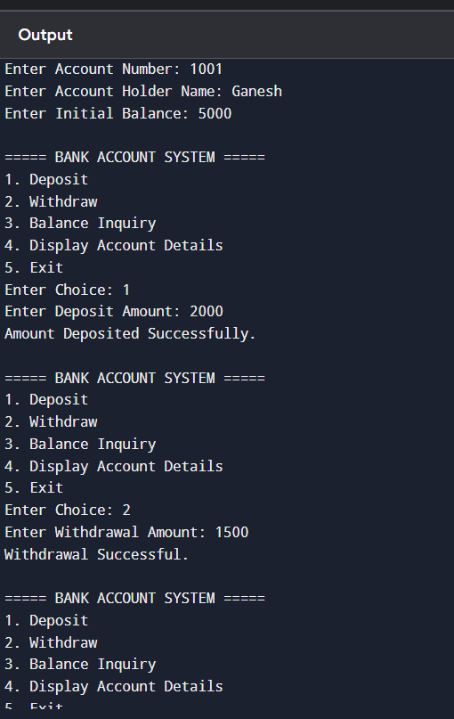
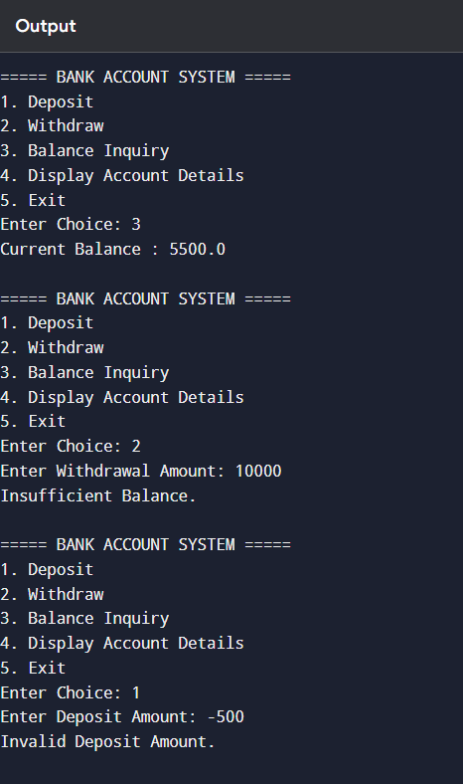

University Admission System using Method Overloading

Create an Admission class that overloads the method calculateFee() for:

  - Undergraduate students,
  - Postgraduate students,
  - Scholarship students.

Display the fee structure based on user input and compare the overloaded method executions. Also, construct suitable test cases to validate each overloaded version.BTL: BL3 (Apply)

import java.util.Scanner;

class Admission {

// Undergraduate Student Fee
public double calculateFee(double tuitionFee) {
return tuitionFee;
}

// Postgraduate Student Fee
public double calculateFee(double tuitionFee, double labFee) {
return tuitionFee + labFee;
}

// Scholarship Student Fee
public double calculateFee(double tuitionFee, double scholarshipAmount, boolean isScholarship) {

if (isScholarship) {
return tuitionFee - scholarshipAmount;
}
return tuitionFee;
}
}

public class Main {

public static void main(String[] args) {

Scanner sc = new Scanner(System.in);
Admission admission = new Admission();

int choice;

do {

System.out.println("\n===== UNIVERSITY ADMISSION SYSTEM =====");
System.out.println("1. Undergraduate Student");
System.out.println("2. Postgraduate Student");
System.out.println("3. Scholarship Student");
System.out.println("4. Exit");

System.out.print("Enter Choice: ");
choice = sc.nextInt();

switch (choice) {

case 1:

System.out.print("Enter Undergraduate Tuition Fee: ");
double ugFee = sc.nextDouble();

System.out.println("Total Fee = " +
admission.calculateFee(ugFee));

break;

case 2:

System.out.print("Enter Tuition Fee: ");
double pgFee = sc.nextDouble();

System.out.print("Enter Lab Fee: ");
double labFee = sc.nextDouble();

System.out.println("Total Fee = " +
admission.calculateFee(pgFee, labFee));

break;

case 3:

System.out.print("Enter Tuition Fee: ");
double fee = sc.nextDouble();

System.out.print("Enter Scholarship Amount: ");
double scholarship = sc.nextDouble();

System.out.println("Total Fee = " +
admission.calculateFee(fee, scholarship, true));

break;

case 4:

System.out.println("Thank You!");

break;

default:

System.out.println("Invalid Choice.");
}

} while (choice != 4);

sc.close();
}
}

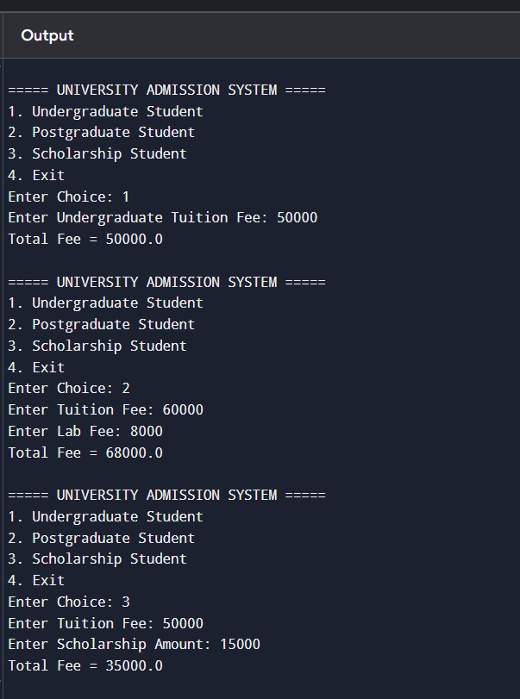

Hospital Management System using Interfaces

Develop a hospital management system with an interface MedicalRecord containing methods addRecord() and displayRecord(). Implement the interface in classes Patient and Doctor. Demonstrate interface-based abstraction and object interaction. Also, construct suitable test cases to validate record creation and display.BTL: BL3 (Apply)
import java.util.Scanner;

// Interface
interface MedicalRecord {

void addRecord();

void displayRecord();
}

// Patient Class
class Patient implements MedicalRecord {

private int patientId;
private String patientName;
private String disease;

Scanner sc = new Scanner(System.in);

@Override
public void addRecord() {

System.out.print("Enter Patient ID: ");
patientId = sc.nextInt();

sc.nextLine();

System.out.print("Enter Patient Name: ");
patientName = sc.nextLine();

System.out.print("Enter Disease: ");
disease = sc.nextLine();
}

@Override
public void displayRecord() {

System.out.println("\n------ Patient Record ------");
System.out.println("Patient ID : " + patientId);
System.out.println("Patient Name : " + patientName);
System.out.println("Disease : " + disease);
}
}

// Doctor Class
class Doctor implements MedicalRecord {

private int doctorId;
private String doctorName;
private String specialization;

Scanner sc = new Scanner(System.in);

@Override
public void addRecord() {

System.out.print("Enter Doctor ID: ");
doctorId = sc.nextInt();

sc.nextLine();

System.out.print("Enter Doctor Name: ");
doctorName = sc.nextLine();

System.out.print("Enter Specialization: ");
specialization = sc.nextLine();
}

@Override
public void displayRecord() {

System.out.println("\n------ Doctor Record ------");
System.out.println("Doctor ID : " + doctorId);
System.out.println("Doctor Name : " + doctorName);
System.out.println("Specialization : " + specialization);
}
}

// Main Class
public class Main {

public static void main(String[] args) {

Scanner sc = new Scanner(System.in);

MedicalRecord record;

int choice;

do {

System.out.println("\n===== HOSPITAL MANAGEMENT SYSTEM =====");
System.out.println("1. Patient Record");
System.out.println("2. Doctor Record");
System.out.println("3. Exit");

System.out.print("Enter Choice: ");
choice = sc.nextInt();

switch (choice) {

case 1:

record = new Patient();

record.addRecord();

record.displayRecord();

break;

case 2:

record = new Doctor();

record.addRecord();

record.displayRecord();

break;

case 3:

System.out.println("Thank You!");

break;

default:

System.out.println("Invalid Choice.");
}

} while (choice != 3);

sc.close();
}
}

